AUTOMATED TOLL‐BOOTH MACHINE
Automated toll booth machine detects the presence of vehicle with the help of a sensor 1 in front of the vehicle (on the barrier that is initially closed). This is done using sensor 2 (on the road) that counts number of clock cycles during the time interval the vehicle tyre passes over the sensor 2. It further distinguishes between different vehicles by measuring tyre radius of the vehicle. Specific toll for each vehicle is predefined in the code. If the driver has paid the required toll then the barrier opens and remain opened till the vehicle crosses it. As the vehicle crosses the barrier it again closes.
In the code we take presence of vehicle, vehicle type (integer input) and payment done as inputs that decides whether the barrier will open or not. A light indicates the opening of barrier.
STATE DIAGRAM‐
Vehicle=0 Light=0 Toll_pay=0
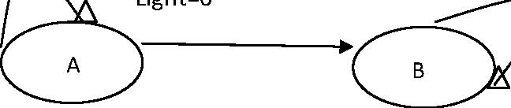
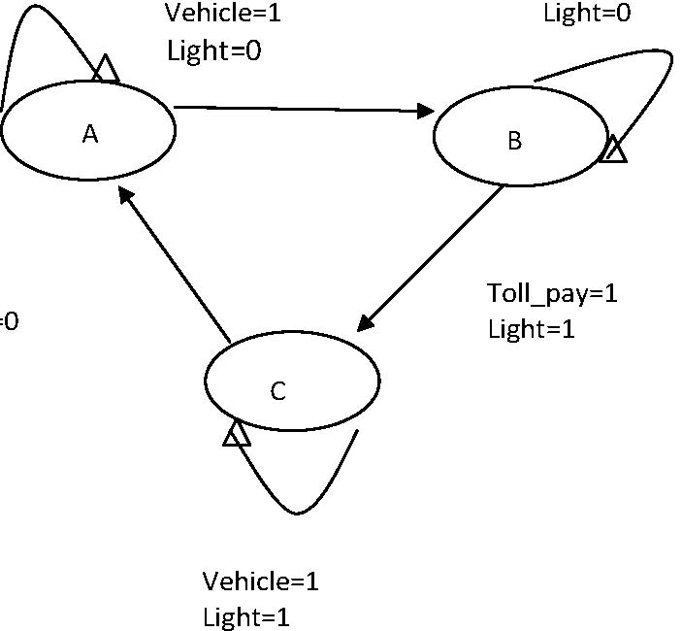
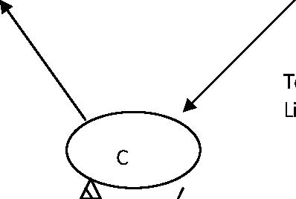Vehicle=0 Light=0

Toll calculation
